Minutes of the meeting held on Wednesday 16th April 2025 at 7.00pm

PRESENT: Cllr Mulligan– Chair, Cllr Bendall. Cllr King, Cllr Parsons, Cllr Hamilton, Cllr Slater (Late Arrival)

ALSO IN ATTENDANCE: - Mrs S Baker (Clerk), CC Cllr Stephan Fifield.
VISITORS:- None

49/25 PUBLIC QUESTION TIME – None
50/25 APOLOGIES AND REASONS FOR ABSENCE – Cllr Hetterley, Cllr Mills. Cllr Blackie

51/25 CODE OF CONDUCT
166.1.18 Declaration of Interest in Items on the Agenda
P. Mulligan Expenses. Agenda Item 10 Planning 25/00509/TCONR
166.2.18 Updates to Members Register of Interests
None
52/25 MINUTES OF MEETING HELD ON 12th March 2025
The minutes of the meeting held on the 12^{th of} March 2025 were signed as a true record.

53/25 MATTERS ARISING FROM THE MINUTES OF MEETING HELD ON 12 March 2025
54/25 COMMUNITY ISSUES AND PROJECTS
Community Issues
Playing Fields Update
The Clerk reported the Rospa safety inspection is complete. The report has been distributed to the Council for consideration.

Cllr Mulligan reported that he had installed the dog waste bag dispensers in the playing field. Unfortunately, someone has been taking them and tying them to the fence. This is a waste of Council funds and CCTV will now be considered. IT will be on the agenda at the next meeting.

The Clerk said she has been approached by a resident in regard to use of a football pitch. Avening U18’s have joined the Stroud league and are looking for somewhere to play. It was agreed that although it isn’t a definite no, the Council needs more information as to the requirements.
The Clerk has received notification from the School that they intend weather permitting to hold their sports day on 3rd July. The filed will be marked out a few days prior. The Clerk will ask the ground maintenance contractor to work around the school schedule.

Memorial Hall
Cllr Mulligan said he had received two quotes for the memorial hall roof. There is very little between them in view of costs and scheme of work. Mr Billingham’s quote is cheaper by a few hundred pound. It was agreed to offer the work to Mr Bullingham on condition he can guarantee work commences at the start of the school summer holidays.

The Athelstan Trust have informed the Clerk that the Education Department asked for further clarification on the lease, before signing. The Athelston Trust has provided this and is waiting for a decision.

Defibrillator
Cllr Mulligan said on attempting to install the defib in the phone box, it was discovered the phone box has a metal back not word as expected. Cllr Mulligan is now trying to locate the correct bolts for metal fixing.
Phone Box Refurbishment
Work on the phone box refurbishment has started. A crack in the metal base has been discovered, that needs welding. Mr Mulligan will contact a local person with the equipment and knowledge to carry this work out.
Annual Parish Meeting
The Clerk said the Annual Parish Meeting must be carried out before 1st June.
Cllr Fifield agreed to give a talk on the planned devolution of councils. Cllr Mulligan will speak to the Café to see if the venue could be used on a Saturday morning. If unavailable, the Memorial Jhall can be used.
Parish Plan Update
No report available
55/25 TRAFFIC & HIGHWAYS
Cllr King said that no action has been taken regarding the repair of Avening Court Wall. This is causing concern for local residents. The Clerk will contact the Highways Manager for an update.
Cllr Mulligan reported that contractors working in Old Hill had travelled from Durham. Cllr Fifield said he would look into the reasoning behind this.
56/25 FINANCE
- Finance Sub Committee meeting held 11 April:
Reviewed roll over spend on 31 March 2025. Moved £13,350 into Ring Fenced area (for playing field path, playing field ash dieback and phone box refurb) to increase Ring Fenced sum to £48,886.
Due to Youth Club closure, £1,400 Ring Fence grant moved to playing field path.
Agreed to proceed with update of Hall cinema system
Agreed to obtain quotes for 2x noticeboards (Park and Nags Head)
Agreed to offer reasonable financial support, if required, to Mayday /VE Anniversary village event.
Financial Year End Position as at 31/3/25:
Net Spend in Year £54,391
Bank Balance at 31 Mar £87,508
Split: Ring fenced £48,886
Reserves £38,622
New Fin Year 25/26 (see separate Report):
Net Spend to date £2,825
Bank Balance to 14 Apr £88,385

- The Parish Council approved bills for payment.
- The Clerk has received notification that the precept is due to be received later in April. The Parish Council agreed that once the payment is received to pay the grants agreed.
- Pigface Grant Request- The Clerk has received a request from Mr Lindley for funding towards the Pig Face event. The Clerk requested Mr Lindley complete a grant application form, and because it was a late application, the Parish council may consider taking the funds from the reserves. Mr Lindley has refused to complete grant application form. The Parish Council agreed that this request cannot be considered without the requisite form completed. The Clerk will inform Mr Lindley of the Parish Council’s decision.
- The Clerk reported that she has met with the internal auditor and handed over the accounts for 2024/25. A follow up meeting will be held on the 5th May to sign off the internal audit.
57/25 POLICE REPORT – Unavailable.
58/25 DISTRICT COUNILLORS REPORT – Appendix 1
59/25 COUNCTY COUNCILLOR REPORT – Cllr Fifield reported that the closure of Wiltshire
Bridge was resolved quickly. Highways manager Gill Portlock has offered to visit the Parish And Walk the route with Parish/County and District Councillors in attendance to discuss issues and ongoing maintenance problems. Cllr Fifield will arrange a mutually suitable date and time.
Avening Playgroup have been successful in achieving a levelling up grant from Gloucester County Council.
Cllr Fifield said he has been approached by a woman in Rectory Lane complaining about the speed of traffic. This is obviously a village issue and something that can be discussed at the Highways Manger meeting.

60/25 PLANNING AND TREE WORKS
New Planning Applications

25/00350/FUL10 Sandford Leaze - Erection of two storey side extension – No Objections

25/00694/COMPLY - 51 Nags Head Lane Compliance with condition 4 (details) of permission 24/01179/FUL- Alterations and extensions to convert garage, erection of canopy and relocation of parking area and existing vehicular access and condition 3 (details) of consent 24/01180/LBC- Alterations and extensions to convert garage, erection of canopy and relocation of parking area and existing vehicular access. - No Objections.

25/00916/COMPLY - Old Quarries Rectory Lane

Partial compliance with conditions 3 (Sample materials), 7 (Timber boarding) and 25 (Artificial roosting nesting) of permission 22/03666/FUL in respect of the East Gate Dwellings and Lodge - Change of use of existing buildings from residential institution (C2 use) to residential (C3 use) to form a total of 11 no. dwellings, through demolition of modern extensions, internal alterations and extensions, demolition of modern institutional buildings and replacement with new dwellings, associated garaging, landscaping, construction of new wall in alignment of historic walled garden and associated works. - No Objections
61/25 Planning Correspondence and Decisions
24/03783/FUL 12 Star Lane Erection of replacement garage with ancillary accommodation over - Permitte24/03832/FUL1 Tetbury Hill Creation of new vehicular access and driveway and replacement boundary walling - Permitted

25/00018/LBC 31 Nags Head Lane Carry out essential maintenance to the property by repointing the front exterior wall to the right-hand side only. This will preserve the fabric of the building and prevent water ingress. The work will involve removing all the old cement and flaking lime mortar down to the bed joint and repointing with lime mortar, locally sourced sharp washed sand and stone grit throughout - Permitted

25/00063/FUL21 West End Erection of two-storey side extension, alteration to front porch and the re cladding of dwelling – Permitted

25/00509/TCONR Brook House Hampton Hill Large, mature poplar' Re-pollard below previous pollard leaving the new pollard at 6 meters in height – No Objection

62/25 CORRESPONDENCE
The Clerk reported that very little correspondence has been available this month due to the coming County Council Elections.
63/25 COUNCILLORS
Cllr Bendall said that he had received enquiries as to how the bins would be collected during the four-week road closure at New Inn Lane to the junction with Orchard Fields. Cllr Bendall was informed that the bins should be taken wheeled below the road closure sign, near the pub for collection.
Cllr King asked why the youth club has been dissolved. Cllr Hamilton said it was funded by the Education Charity. IT was proving to be very expensive for the few Children who attended. Children who attended the club have now moved to Minchinhampton Youth Club. The Education Charity are researching ways to possibly transport the children to the new venue.
Cllr King said depending on how Pheobe Carter extracts data from GCC for the biodiversity report further funds may be required.
A request has been made to help fund the VE day commemoration. The Clerk said that Parish Councils all over the County were getting involved. It was agreed that in principle it was an event that the Parish Council would like to support, and a decision regarding the level of support would be made via email when an event plan is available.
The Clerk said she will be on annual leave from 6th – 11 May. The agenda will be issued early.
64/25 DATE OF NEXT MEETING
Wednesday 14th May 2025 at 7.00 pm.

The meeting closed at 8.05 pm.

Actions
56/25 | Pay Bills | Clerk
61/25 | Submit Planning response. | Clerk

Appendix 1
It’s the time of year when parishes and councils turn their attention to Annual Parish Meetings and AGMs, so in this edition of my report I look back over the year’s ‘highlights’, and project forward to what is being talked about for the coming year.
Cotswold District Council (CDC): Joe Harris has been the elected CDC leader since the Lib-Dems won a majority in the 2018 election but has decided to step down in May. Joe has been a strong leader and has made a positive contribution to the Local Government Association but at CDC has implemented several controversial initiatives, most notably taking away the importance of Parish Council and public comments on planning applications.
Also stepping down is the popular Council Chair, Nikki Ind, and a vote will take place at the May AGM to elect her replacement.
in the next year, the next phase of the Publica transition will complete, and hopefully a new system will be implemented to provide real-time data on bin collections (and, more importantly, non-collections). We also hope the planning team will be able to recruit more staff and continue with improvements in processing applications and progressing enforcement issues more effectively.
I have reached half way in my 4 year tenure, and if the government plans come to fruition, by the end of my term I’ll be helping to put the lights out at CDC HQ as the district council will be no more.
I can provide you with a summary of the latest financial year accounts upon request, but the headlines are that the state of CDC finances are perilous. In the recent budget meeting, it was confirmed there is still a potential future threat of CDC having to apply for Exceptional Financial Support or issue a section 114 notice should the anticipated budget gap not be closed sufficiently. A forecast budget gap of £1.6m for the next financial year and nearly £5m for the following year needed to be closed through a combination of savings, income generation, and financial management to maintain financial stability.
Gloucestershire County Council (GCC): If you are reading this after 1st May, we now have a new County Council – more about the makeup, leadership, and potential future direction in the next edition of this report.
I do hope that the elected councillor for our patch will play an active role in the community and regularly attend parish meetings – I certainly find these the most effective way to engage with the community.
Litter: This term we have learned that fast food outlets are very cooperative when the remains of their products are thrown from cars, but dog mess continues to be an annoying issue.
Roads: Several candidates in their GCC election offerings have put special emphasis on our local roads – hopefully they will follow through with positive actions when elected as our roads really are in a shoddy state of disrepair.
Councillor Tony Slater
Cotswold District Council, Representing Grumbolds Ash with Avening.
email: Tony.slater@cotswold.gov.uk Tel: 07793669930
Other updates and information for Parish Councils:
DEVOLUTION FOR GLOUCESTERSHIRE - UPDATE
On 5 February it was announced that Gloucestershire was not included in the devolution priority programme so Gloucestershire County Council (GCC) elections will take place on 1 May 2025.
UNSUNG HEROES
The Unsung Heroes Awards is to acknowledge all the work being done across the district by volunteers who give up their time to help others. Residents and businesses have nominated people in their communities who they think have made a difference, from individuals who give up their time to help neighbours, to members of local groups who volunteer to deliver local projects.
This is a rolling scheme with winners announced at every Full Council meeting going forward. Please nominate your Unsung Hero here: www.cotswold.gov.uk/unsungheroes
HOW TO REPORT POTHOLES
I recommend using this link, especially if you have a smartphone and can take a photograph of the pothole and identify the exact position. It is more efficient than emailing the council as officers get a daily schedule of these alerts.
Gloucestershire County Council, report a pothole:
https://www.gloucestershire.gov.uk/highways/roads/your-highways-report-it/
FIX MY STREET
Report, view, or discuss local problems like graffiti, fly tipping, broken paving slabs, or street lighting. This reports back to the appropriate Council: LINK
REPORT IT
https://www.cotswold.gov.uk/report-it/
New forms for reporting graffiti, overflowing bins, dog fouling and street cleaning are now live on the Cotswold District Council Website.
A map pin drop allowing for what3words location submissions can be used.

2025 DISTRICT COUNCILLOR ANNUAL FINANCIAL REPORT FOR PARISHES
The state of CDC finances is perilous. In the recent budget meeting, it was confirmed there is still a potential future threat of CDC having to apply for Exceptional Financial Support or issue a section 114 notice should the anticipated budget gap not be closed sufficiently.

A significant budget gap was identified in the February 2023 and February 2024 MTFS (Medium-Term Financial Strategy) forecasts. The indicative position outlined for 2025/26 through to 2027/28 was an unfunded budget gap of £4,697,000 (£10,48,000 2025/26 to 2028/29). The decision to return the majority of services from Publica to the Council (November 2023), without further mitigating action can be expected to have increased the unfunded budget gap over the last 12 months. The budget gap forecast over the medium-term must be closed to maintain financial sustainability. Should the budget gap not be closed sufficiently, EFS (Exceptional Financial Support) cannot be ruled out in future.

A forecast budget gap of £1.6 million for the next financial year and nearly £5 million for the following year needed to be closed through a combination of savings, income generation, and financial management to maintain financial stability.

£625,000 in savings was projected for 2025-26 through operational efficiencies in customer service and waste management.

Rising costs included an additional £450,000 in general expenditure and £1,000,000 in increased contract pay and energy inflation costs.

The Council’s capital fund (Capital Reserves), originally £56 million from the 1997 housing stock sale, has been gradually used up. With reserves nearly depleted, the Council will need to carefully manage remaining funds to reduce pressure on revenue budgets.

The government’s devolution white paper suggested potential restructuring, including the creation of unitary councils, which could have led to the abolition of the current Council by April 2028. Financial planning incorporated this uncertainty to ensure sustainability. The council will still need to produce a MTFS as if it will continue to exist beyond the likely devolution.
From Council Meeting 24 February 2025 - (link to full Council Budget Meeting papers)
Budget 2025/26 and Medium-Term Financial Strategy
• Council increases Council Tax by the maximum permissible level - Band D rate by £5 (just under 10p per week) from £153.93 to £158.93. Band D property in 2025/26 (increase of £5)
- Adjustments to parking charges were expected to contribute an additional £90,000.
- The garden waste collection fee raised to £69 per bin per annum to ensure cost recovery for the service.
• The budget for PR and communications increased by 41% to £405,000, funding a six-strong team.
• The Council had spent £60,000 on a rebrand.
• The administration had scrapped the popular ‘free after three’ scheme and increased parking fees by 15%.
• The Council faces challenges with its Medium-Term Financial Strategy (MTFS) and needed to focus on scrutinising and challenging financial decisions.
• The Publica transition process had had a significant impact on the Council's finances, with costs escalating from £200,000 to £1,100,000 by the end of Phase 1.
• The ongoing costs of delivering services in-house had increased by £780,000 per year.

Financial Context and Budget Gap
- The budget and Medium-Term Financial Strategy (MTFS) reflect ongoing financial pressures.
- A significant budget gap identified:
  - £4,697,000 unfunded gap for 2025/26 to 2027/28
  - £10,487,000 total forecast gap from 2025/26 to 2028/29
- Revised savings and transformation strategies are necessary.
- Transition of services from Publica to the Council (Nov 2023) increased the budget gap.

External Financial Pressures
- Inflation and interest rate uncertainties impact 2025/26 budget and MTFS.
- December 2024 Government White Paper ("English Devolution") suggests local government reorganisation, possibly by April 2027/2028.
- Section 114 notices (declaring financial unsustainability) issued by several councils in recent years.
- Cotswold District Council is not at immediate risk, but the gap must be closed to avoid future risk.

Reforms & Funding Outlook
- Local Government Finance Reforms delayed to April 2026.
- December 2024 consultation on funding reform closed in Feb 2025.
- Likely funding shifts away from low-need/high-tax base authorities (likely Cotswold).
- Business Rates Retention reset, New Homes Bonus cessation, and devolution impacts suggest reduced future funding for Shire Districts.

Council Tax & Settlement 2025/26
- Proposed Council Tax increase: +£5 (Band D from £153.93 to £158.93).
- Final settlement announced Feb 2025 (for 2025/26 only):
  - 2.99% or £5 increase permitted for shire districts
  - New Homes Bonus extended one more year
  - Grants and funding changes:
    - Rural Services Delivery Grant abolished
    - New grants introduced:
    - Recovery Grant (£600,000)
    - Children’s Services Prevention Grant (£263,000)
    - Adult Social Care Grant (+£880,000)
    - Domestic Abuse Grant moved to Core Spending Power (CSP)
    - Services Grant abolished
    - Minimum Funding Guarantee threshold reduced (impacting CSP increases)
    - Employer National Insurance Grant of £133,000 included
PUBLICA TRANSITION
Council March 2025 Link here: Detailed Transition Plan
- No 2024/25 MTFS provision for Publica transition phases.
- Phase 1 cost:
- Gross cost: £984,000 (was £937,000)
- Net cost after reductions: £481,000 (was £415,000)
- Cost reductions are front-loaded; Phase 2 unlikely to realize similar savings.
- Budget Pressures, Inflation and Risk
- The table below sets out the impact on the Council’s budget from demand and inflationary pressures, impact on fees and charges income, and the risk allowance included in the revenue budget and MTFS for major contracts.

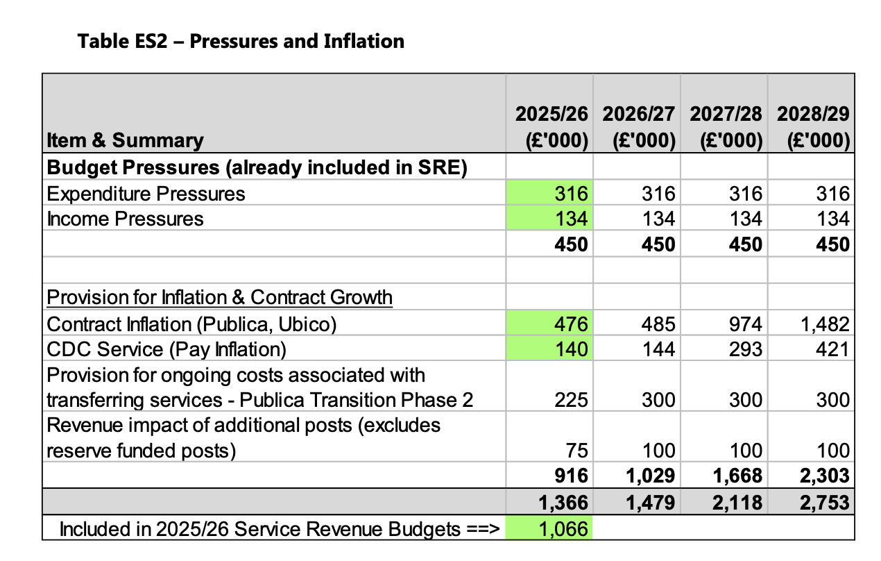

Phase 2 Publica Transition Planning
- MTFS assumes higher costs due to pension contributions and less service sharing.
- Cabinet/Council to review Phase 2 Transition Plan in March 2025.
- Estimated cost increase: £300,000 per year for:
  - Property & Estates
  - Leisure Management
  - Waste & Recycling (contract management)
  - Project & Programme support
- Initially the transition costs were estimated at £200,000 for the transition. Phase 1 has cost £1,100,000 and £150,000 per year enduring annual cost which is now £780,000. There are one off costs for redundancy of £300,000 for phase 1 and £300,000 for phase 2 (see in above table).

Phase 2 Staffing and Cost Implications
- Scope: 60 roles identified; 10 posts will transfer from Publica to Cotswold District Council. 30 roles are fragmented.
- Cost Drivers:
  - New service structures reflect less role-sharing due to 'sovereign' council arrangements.
  - Transferring staff become eligible for the Local Government Pension Scheme (LGPS), increasing employer contributions from 5% (Royal London) to 20.7%.
  - Assumes no opt-outs from LGPS, though actual opt-out rates are expected to be low.
- At-Risk Roles: A small number of posts are at risk, with estimated costs for redundancy and pension strain included.

One-Off Costs
- £225,000 of £500,000 transition funding (2025/26 Budget) allocated for Phase 2 support.
- £300,000 estimated for redundancy and pension strain, to be funded from one-off reserves.
As set out in 2025/26 Revenue Budget, Capital Programme and Medium-Term Financial Strategy report approved by Council on 24 February 2025

Additional Strategic Roles (to support transformation)
- Funded from reserves or designated streams:
  - Head of Organisational Development and People (Growth, revenue budget)
  - Transformation Lead (Reserve)
  - Transformation Support – Project Management (Reserve)
  - Strategic Housing Support (Council Tax Second Homes Premium)
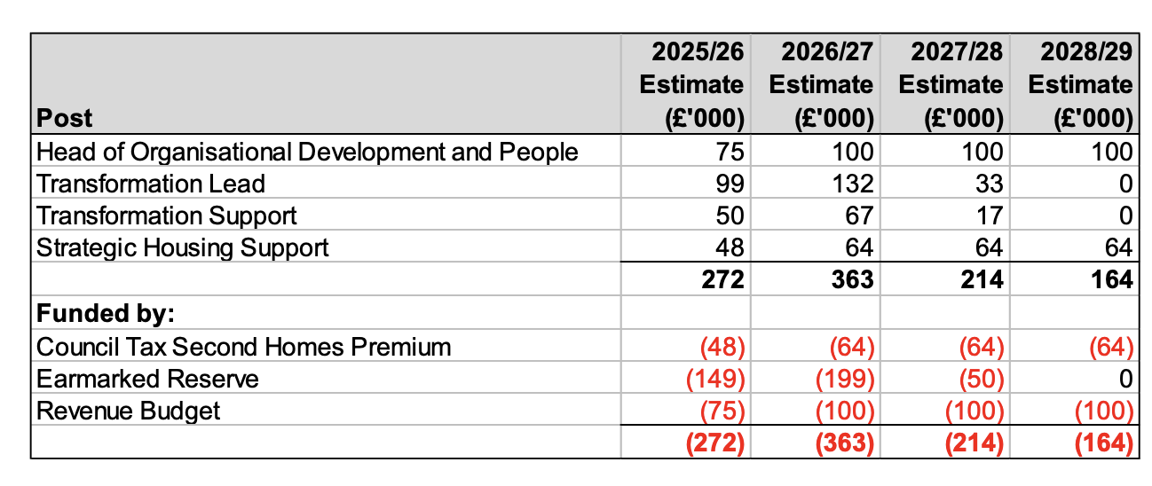

Balanced Budget Requirement & MTFS Outlook
- The Council is legally required to set a balanced budget.
- For 2025/26, a balanced budget is achieved, with a surplus transferred to the Financial Resilience Reserve.
- Future projected budget gaps (unmitigated):
  - 2026/27: £1,589,000
  - 2027/28: £4,879,000
  - 2028/29: £6,282,000
- These projections do not include any savings or cost reduction strategies yet to be identified.
The February 2024/25 MTFS did not include any budget provision for Phase 1, or any subsequent phase associated with the transfer of services from Publica to the Council.

