1911 Census – Avening – Enumerator’s Summary

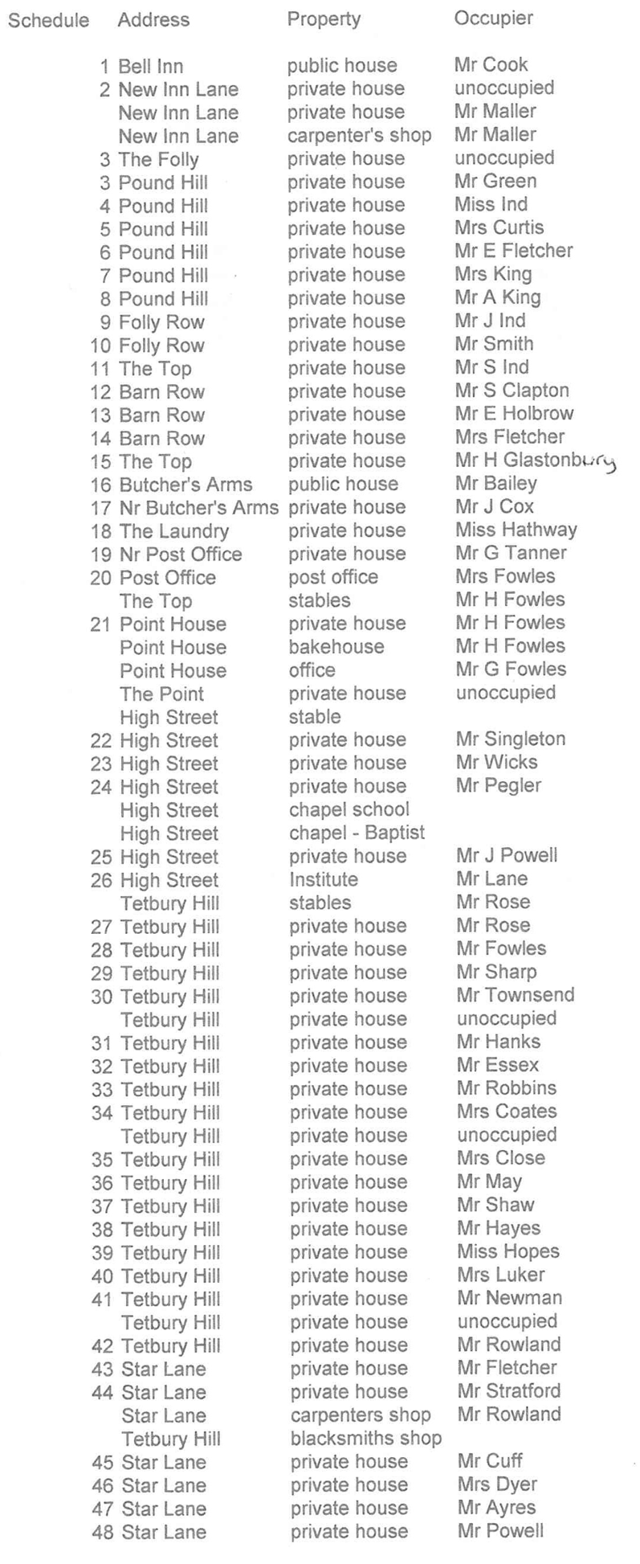
Start from Bell Inn. Proceed up New Inn Lane along the road termed the Top to the main road at Point. Then follow main road towards Tetbury as far as Tetbury Hill. Proceed up Star Lane to White Wall Barn. Return to Cross. Then follow main road to Minchinhampton to the point in Hampton Hill above the last house. Then follow the Bye Road called Steps Lane till it meets the main road to Stroud. Thence return to starting point at Bell Inn.

****************

Carpenter’s house and shop. The Folly and Folly Row, Barn Row with cottages opposite. Point House, Butchers Arms and cottages, Post Office and cottages, High Street, Cross Inn and cottages, Institute, Tetbury Hill, Police Station, Star Lane, Brookside House and cottages, Avening Court Lodge, Leonards Brook, Brookside cottages, The Old Hill, house on Hampton Hill, Rectory and cottages, Rectory Lane, The Old Rectory, Church Street, Sanfords, Wood House Farm.

Page Inhabited Uninhabited Males Females Total

- 21 4 42 46 88
- 17 3 29 29 58
- 20 1 37 29 66
- 13 8 22 31 53
- 22 2 56 45 101
- 12 - 24 28 52

Total 105. 18 210 208 418

Enumerator: Mr Alfred S Morris

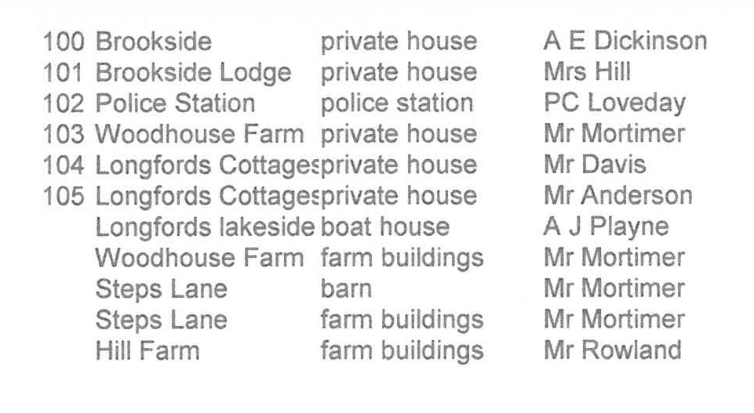
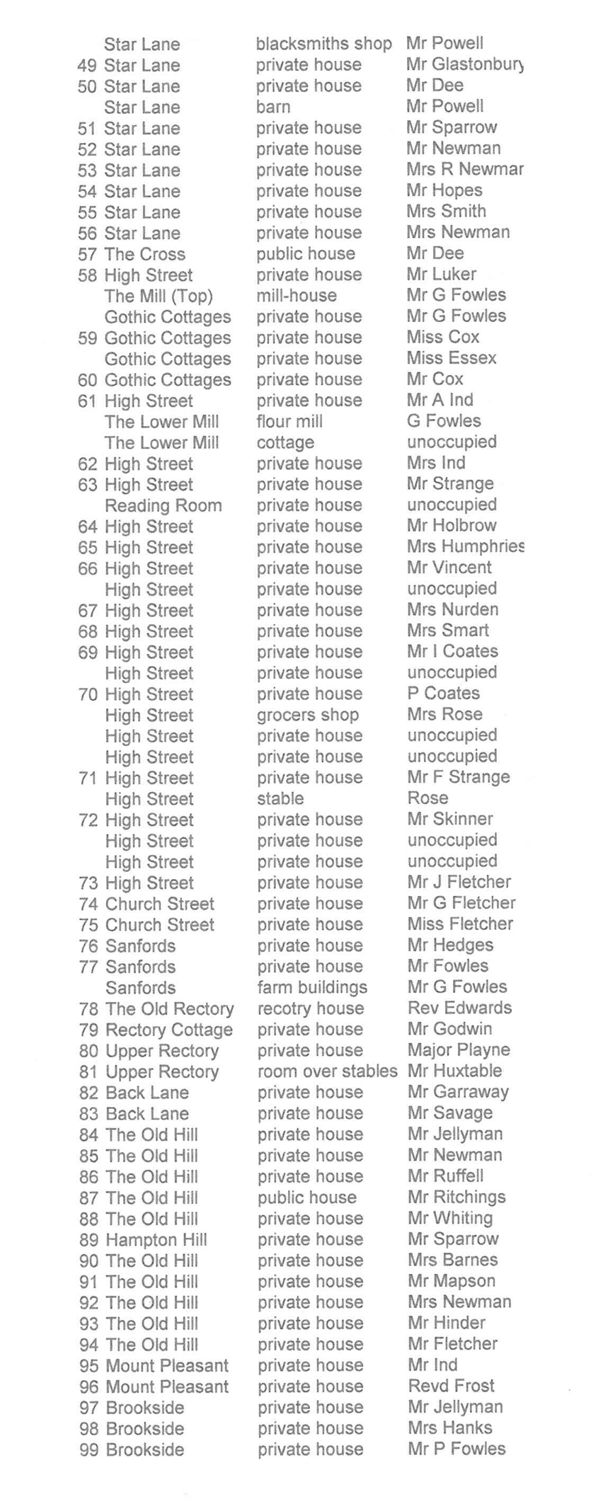
k
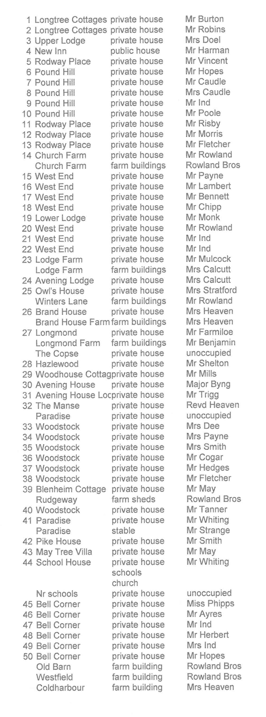
Start at Bell Inn. Follow main road from Avening to Stroud going NW to the boundary of the parish near the Weigh-Bridge Inn. Then follow the boundary line between Avening and Horsley parishes to the point where at the catch pike it crosses the main road from Tetbury to Avening. Then follow the road to a point in Tetbury Hill where a path called “Little Hill” meets the main road. Then follow this path till it reaches the road called New Inn Lane. Proceed down New Inn Lane to the starting point at the Bell Inn.

****************

Bell Corner, church and schools with cottages near Paradise, Woodstock, Avening House and Lodge, Woodhouse Cottage, Longmont Farm, Longfords cottages in Hazlewood, Brand House Farm, cottage in copse, Longtree Barn and cottages, Upper Lodge, Pound Hill, Rodway Place, New Inn and cottages, Church Farm and cottages, West End, Avening Lodge, The Owl’s House.

Page Inhabited Uninhabited Males Females Total

1 23 0 52 52 104
2 18 2 38 38 76
3 9 1 26 19 45

Total 50 3 116 109 225

Enumerator: Mr FW Fowles

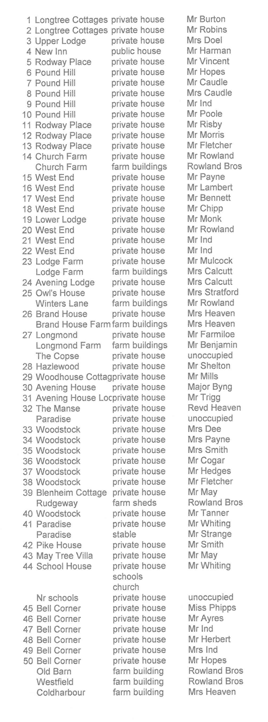
Cottages in Mays Lane, Avening Court and Lodge, the Washpound, Hamlet of Nags Head, Star Farm, The Ridges Farm, Summerwell Farm, The Warren Farm.

Contents of Detached Portion – Lowesmore Farm and cottages, Red Shed cottages, Aston Farm and cottages.

Page Inhabited Uninhabited Males Females Total

- 14 0 42 39 81
2 18 5 40 38 78
3 7 4 11 10 21

Total 39 9 93 87 180

Enumerator: Mr Fredk W Morris

