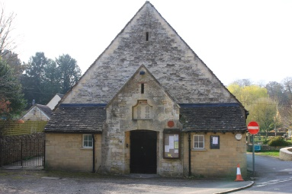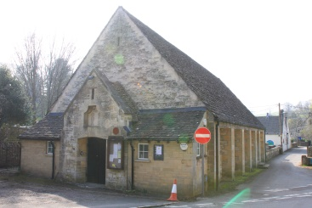

2018

Appeal

1914

Roof

Your Village Hall Needs You!



Our village hall was built to commemorate the fallen of WW1, but after almost 100 years of service, the **Memorial Hall** is in need of some structural repairs, including a partial new roof. Many of the tiles will be re-used, but we will need to buy some new, expensive Cotswold stone tiles.

In addition to seeking grant funding, we are offering the opportunity for everyone to **‘buy a tile’ and remember a hero** for just £10 per tile.

If you would like to, you also have the opportunity to tell us your story of a fallen family member, or anyone who served and returned from any conflict, and we will preserve it in a commemorative book for future generations to see.

|  |  |
| --- | --- |
| **Your name** |  |
| **Your address** |  |
| **No. of tiles @£10** | Please make cheques to Avening Parish Council, or contact [parishclerk@avening-pc.gov.uk](mailto:parishclerk@avening-pc.gov.uk) for bank details |
| **Your hero’s name** |  |
| **Any relevant military details e.g. rank, service etc.** |  |
| **Their story (the box will expand if needed)** |  |

Return the completed form to the Clerk (see website or Villager), or email it to [parishclerk@avening-pc.gov.uk](mailto:parishclerk@avening-pc.gov.uk)